
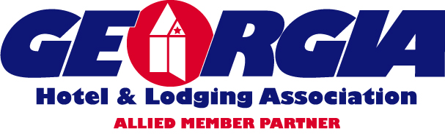

At Your Service…

Your Needs. . .

Voluntary and Affordable Health Care Coverage for your employees

Our Solution. . . . The GHLA EasyPlan!

Health insurance choices tailored specifically for the Hospitality Industry

The EasyPlan you have been looking for:

- Special Rates for GHLA Members—No census required!
- Voluntary – Employer can contribute some, all or none of the premium!
- Available for Full-Time, Part-Time, Seasonal or Contract Employees.
- Premiums ranging from $85 to $125 month per Employee.
- NO Social Security Number required.
- Attract Career Employees & Increase Retention.
- Easy or NO Administration!
Give us 15 Minutes to show you how you can afford benefits for all of your employees.

Call The Meridian Group
770-698-5060
www.themeridiangroup.biz
Se Habla Español

